Guide for including children and
young people in reportable conduct investigations during COVID-19

Contents
Contents 2
Introduction 1
Additional guidance 1
Context 2
Environment 2
Safety 2
Privacy 2
Developmental age and capacities 2
Technology 2
Issues to consider in planning interviews 3
Environment 3
Safety 4
Privacy 4
Developmental age and capacities 5
Technology 5
Issues to consider during the interview 6
Environment 6
Safety 6
Privacy 7
Technology 7
Issues to consider after the interview 7
Additional resources 9
Commission for Children and Young People
Level 18, 570 Bourke Street, Melbourne Victoria 3000
Phone (Free call) : 1300 78 29 78
Phone: (03) 8601 5281
Email: contact@ccyp.vic.gov.au
Website: ccyp.vic.gov.au

Introduction
The COVID-19 pandemic has impacted our entire community and changed the way organisations engage with children and young people. It has also affected the physical and mental health of many children, young people and adults.
To best support the prevention of, and appropriate responses to, allegations of child abuse, organisations must continue to operate in accordance with the Reportable Conduct Scheme and the Child Safe Standards.
Some issues arising from COVID-19 are new, requiring organisations to think differently about how to engage children and young people and ensure their safety.
Even during a pandemic, investigations need to be conducted, and children and young people need to be included in interviews unless there is good reason not to.
Organisations have asked the Commission for Children and Young People for advice about how to interview children and young people for Reportable Conduct Scheme investigations during the pandemic. This guidance has been prepared to assist organisations in ensuring children and young people participate meaningfully and safely. In developing this guide, the Commission sought views of expert stakeholders, both directly and through available literature.
This guide is advisory only. Approaches will vary across different contexts. We acknowledge that, in some circumstances, the pandemic poses no need to change interview processes. In other circumstances, however, changes may be required, due to current Chief Health Officer directives or to reduce infection risks. Planning interviews is crucial to identify potential difficulties and organise solutions.
The aim of this guide is to highlight some key impacts of COVID-19 and issues to consider when planning and conducting interviews.

Additional guidance
This resource is a supplement to the Commission’s existing guidance:
- Guide for including children and young people in reportable conduct investigations
- Guidance for organisations investigating a reportable conduct allegation.
These provide the essential framework for conducting interviews, and this guide is designed to accompany them.
Despite the challenges posed by the pandemic, it is still important to ensure interviews with children and young people are:
- culturally safe for Aboriginal children and young people and those from culturally and linguistically diverse backgrounds
- trauma-informed
- safe and accessible for children and young people with disability.
Guidance related to these areas should be reviewed when planning an interview. Useful resources are listed in Additional resources at the end of this guide.

Context
The pandemic has raised many issues to consider including whether interviewers should be in the same room as a child or young person, whether Personal Protective Equipment (PPE) such as a face masks are required, and whether visits can take place at the child or young person’s home or school. Careful planning, creative solutions and the opportunity to use technology can ensure that interviewers are well prepared for any challenges that may arise.
This guide will help you to use technology effectively and meet the challenges of face-to-face interviews that have arisen during the pandemic. It leads you through some considerations for three phrases:
- planning the interview
- during the interview
- after the interview.
In each of the three phases, the following five key factors should be considered.

Environment
When interviews are conducted remotely, the interviewer has less control over the environment. This can impact privacy, distractions, safety and reliability of technology. Selecting the best location for the interview, and maintaining awareness of the impact of the environment, are key to a successful interview.

Safety
To ensure the physical, psychological and cultural safety of the child or young person, additional measures may be required. This is particularly important when the child or young person is being interviewed remotely (from home) and the subject of the allegation may be a family member or carer, or where the child or young person may be distressed and need support or comfort.

Privacy
Privacy is important during sensitive interviews, for reasons of confidentiality and safety, and to minimise distraction. It may be more difficult to ensure privacy when conducting interviews remotely.

Developmental age and capacities
Age, experience and developmental capacities of the child or young person can have marked impact on the accessibility of technology options available, the ease with which the child or young person can use them without a third person present, their ability to sustain attention during the interview and how rapport can be established and maintained.

Technology
Technology brings many benefits, including ease of recording, increased accessibility for some, and reduced travel time. Research indicates little difference in the accuracy and detail of information reported by children or young people during video interviews compared to face-to-face interviews. Indeed, just as some children and young people will feel less comfortable being interviewed remotely, others prefer the greater anonymity that video allows.
In addition to the potential benefits, technology also brings challenges associated with access to computers and a reliable internet service, reduced visibility, potential privacy issues, and lack of direct access to the child or young person. We have drawn on the guidance and considerations recommended for telehealth, which cover similar concerns related to privacy, ethics, technology and safety. For additional guidance, see Additional resources at the end of this guide.

Issues to consider in planning interviews

Environment
Knowing about the environment in advance empowers you to adapt the interview format and structure accordingly. Consider the child or young person’s situation and preferences and review the available options to find the best solution.
Considerations include:
- The best interview method (face-to-face, video, phone or combination)
- Interview location options and pros and cons of each (child or young person’s home, school, or elsewhere)
- Requirements in the organisation’s existing COVIDSafe Plan and the impact on the interview
- The child or young person’s living arrangements, particularly if participating from home
- Who else will be present in the physical location, for what reason, and how their presence will be managed
- If the subject of allegation is in the home with the child, it is not usually advisable for the interview to take place via video in the home. You may be able to contact a familiar school or other service to host the child for an interview
- Keeping the location private and without intrusion. For example, a ‘Do not disturb’ sign on the door can help, or ensuring other children leave the house
- Whether it is safer to delay the interview, as long as it will not negatively impact the child or the Reportable Conduct Scheme investigation.

Safety
Considerations include:
- Taking into account all aspects of safety including psychological, physical and cultural safety
- Ensure a reliable safety and post-interview support plan is in place before the interview
- The child or young person’s perspectives about what would make them feel safe
- The interviewer’s flexibility in meeting any special requests
- The safety impact of other people overhearing the conversation and how this can be addressed
- Involving the parent/carer/support person where they are not the subject of allegation
- Any disability or special needs of the child or young person
- Ways to help the child or young person feel safe, such as having a comfort toy
- Having a special code word or stop signal to use if safety is compromised
- The interviewer needs to be mindful of how they present to the child in the chosen format. Practice with the technology and notice how your facial expressions, body language and voice come across on-line, to ensure you help the child stay within their window of tolerance (for more information on window of tolerance see page 13 of the Guide for including children and young people in reportable conduct investigations).

Privacy
Privacy and confidentiality are essential to ensure a reliable interview. Having a support person present may or may not be in the child’s best interest.
Be creative and involve the child’s parent, carer or support person in your planning (if appropriate). For example, parks can offer useful open spaces where others cannot overhear.
Considerations include:
- Whether the parent/carer/support person can help ensure a distraction-free and private environment
- Potential for distraction or interruption from others in the household, noise in the environment, or notifications and alerts being received on the computer
- Ensuring the interviewer has an environment where the background and area in view of the camera is appropriate
- Whether the child or young person has access to headphones during the interview
- Whether other people can hear the child
- Confidentiality when an independent third person is present due to the child or young person’s need for augmented communication during the interview.

Developmental age and capacities
Considerations include:
- Whether the child or young person has the developmental capacity to participate in a video interview, and what support they might need
- Whether the child knows what COVIDSafe procedures to expect
- How a child or young person might feel about the interviewer wearing PPE, for example a face mask, if they are unfamiliar with it or not expecting it
- Whether a photo of the interviewer with and without PPE will help establish trust and familiarity
- The child or young person’s window of tolerance and if one session is sufficient (it is harder to focus with video interviewing)
- Whether communication support should be arranged such as an independent third party when augmented communication is used, and how rapport will be established
- How will rapport building be affected, and challenges accommodated? For example, consider suitable icebreaking activities to do online with varying ages and abilities of children and young people.

Technology
The interviewer should choose secure, familiar technology that will not allow intrusions or secret recording. It is important that the interviewer has practiced with the technology and is able to troubleshoot minor problems, such as turning on cameras and microphones.
Considerations include:
- The quality of the child or young person’s hardware or internet link. Bandwidth can be increased by turning off the camera or plugging the device into modem rather than using WiFi
- Ensuring the child or young person has access to reliable technology (e.g. computer, iPad, mobile phone) including a camera. Consider loaning a device if needed
- The child’s access to headphones
- Access to an office where the child or young person can be in a different room, in the same location as the interviewer, and joined by video
- How tech-savvy and comfortable with online communication the child or young person is
- Whether a training and/or practice session would benefit the child
- What technical support (e.g. a colleague, parent, carer or support person, if they are not the subject of allegation) is available to the interviewer and child or young person before and during the interview
- Preparing a technology checklist (e.g. phones fully charged, mobile numbers shared, address of the child or young person’s location in case of emergency, how to connect)
- An alternate plan if the technology fails before or during the interview.
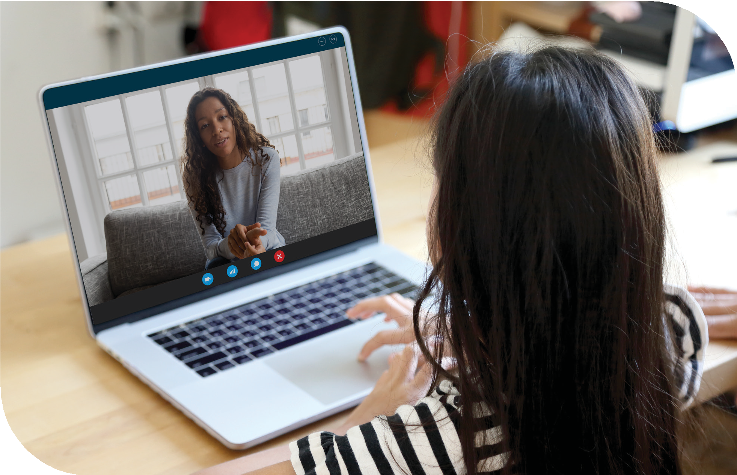

Issues to consider during the interview

Environment
Considerations include:
- Whether the chosen interview location is appropriate considering issues of comfort, access to internet and technology, privacy and minimising distraction
- If useful visual aids and tools are available
- Whether it would be useful to have a sense of the room the child or young person is in (by having the child or young person describe it or show on camera).

Safety
Considerations include:
- Whether the child or young person understands what will happen and what to do if there are any concerns
- Whether the child or young person remembers the special code word or stop signal (if potential safety is an issue)
- Whether infection risks have been minimised in face-to-face interviews (e.g. use of PPE, sanitising rooms and equipment, and setting up interview spaces to provide adequate social distance between the interviewer and the child or young person)
- Considering if cues that the interviewer and child or young person uses to interpret safety are diminished by face masks or cameras (check if the child or young person is managing)
- Be mindful of the interviewer’s voice, tone, facial expressions and posture to ensure a calm, predictable, neutral demeanour
- Consider the need to check in with the child or young person more frequently to see if they need a break, have any questions or feel safe. Use enhanced encouragers as needed, to show active listening (e.g. more obvious head nodding, louder ‘mmm hmm’ when they are speaking).

Privacy
Considerations include:
- Whether the child or young person prefers the camera on or off
- How privacy is assured (e.g. a ‘Do not disturb’ sign has been used on the door if others are around)
- If the child or young person knows how to alert you that someone may be listening or able to overhear.

Technology
Considerations include:
- How comfortable the child or young person is with managing the technology
- Develop a reliable backup plan should the technology fail
- If the child or young person’s and the interviewer’s face will be visible, select the best camera angle to ideally see full face and upper body with no backlighting
- Distractions have been reduced (e.g. incoming notifications and alerts disabled).

Issues to consider after the interview
Considerations include:
- Ensuring the child or young person is feeling ok after the interview and ask what else they would like the adults around them to do
- Letting the child or young person know if a further interview is required
- Enacting the safety and post-interview support plan with their parent, carer or support person
- Ensuring the child or young person knows how to contact the interviewer again if they would like to provide more information, clarify anything said, or schedule another interview.
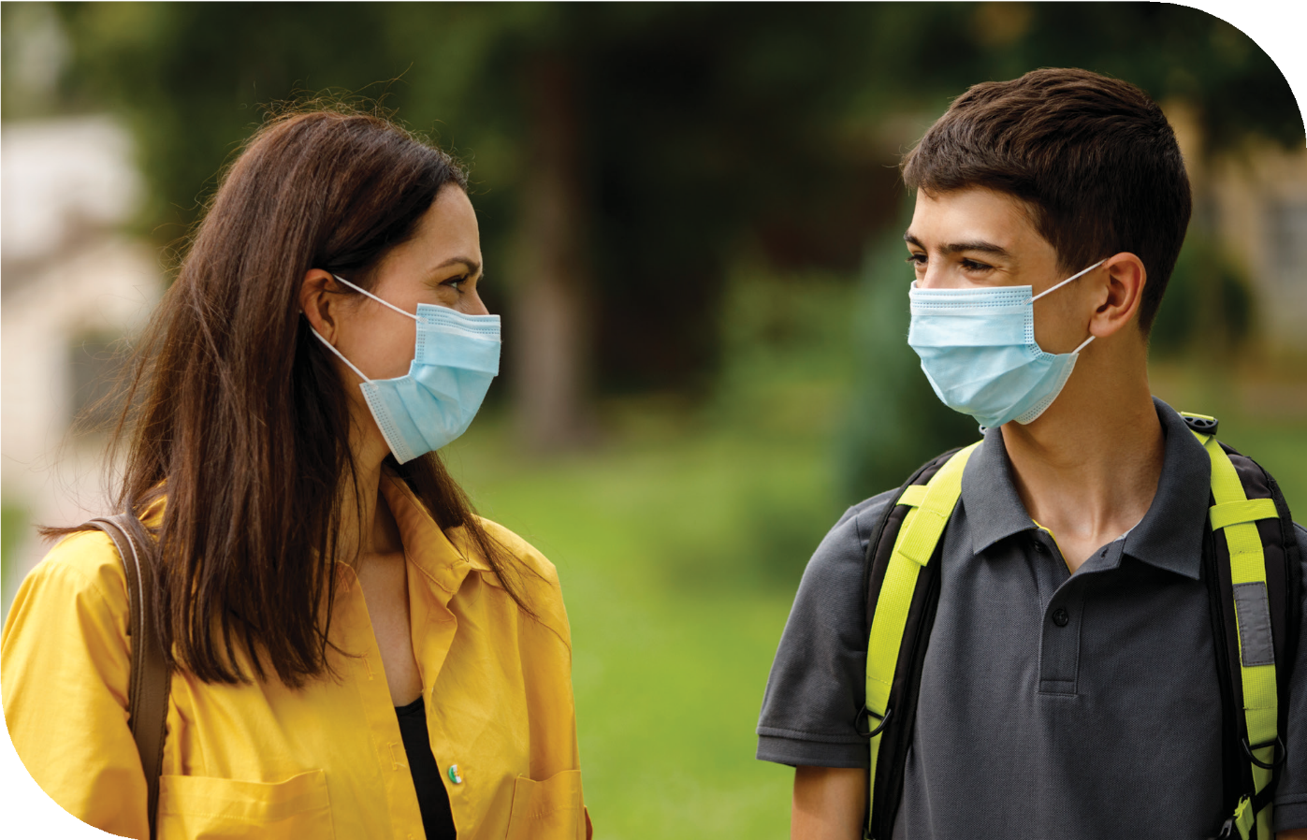

Additional resources
Topic | Resource and provider | For guidance on
Trauma- informed practice during COVID-19 | Blue Knot Foundation (Australia)  Fact sheet: COVID-19 – For practitioners and health and welfare workers – calming the storm  Fact sheet: Face masks and complex trauma | Fact sheet helping workers to assist and support people presenting with emotional distress during COVID-19.  Fact sheet explaining face masks and complex trauma.
COVID-19  coronavirus: Good practice guide for meeting with children via technology | Victoria Legal Aid (Australia)  COVID-19 coronavirus: Good practice guide for meeting with children via technology | Guide developed particularly for lawyers working with clients in child protection, family law and youth crime proceedings but is applicable across other settings.  The guide covers considerations on:  Deciding whether to meet via technology  Be aware of the child’s environment  Deciding on the technology platform  Advance preparation for the meeting  Setting up and starting the meeting  Tips on building rapport via technology  Tips on ensuring the confidentiality of the meeting  Wrapping up the meeting  Planning for further meetings.
Tele-Forensic interviewing | National Children’s Alliance (USA)  Emergency Tele-Forensic Interview Guidelines | Tele-forensic interview guidelines.  Recorded webinar on tele-forensic interviewing.  Tele-forensic resources including:  Interview scenarios  room set up information  planning an interview  during an interview  practices to avoid  additional considerations.
 | State of Michigan Governor’s Task Force on Child Abuse and Neglect and Department of Health and Human Services (USA)  Provisional Tele-Forensic Interview Guidelines | Provisional Tele-forensic Interview Guidelines including:  planning  during the interview  different interview environments  sample interview script.
 | USC Child Interviewing Lab  University of Southern California School of Law (USA)  Child Interviewing Lab Tele-Forensic Interview Protocol  Click ‘Download’ on the website to access | Tele-forensic Interview Protocol including:  Child and interviewer set-up  Child-friendly resources/activities during a break in the interview.
 | American Psychological Association (USA)  Tele-forensic interviewing to elicit children’s evidence – Benefits, risks, and practical considerations | Journal article discussing benefits and risks associated with tele-forensic interviewing.  Access to this article is at a cost.
 | Baltimore Child Abuse Centre (USA)  Forensic Interview Toolbox Training | Videos about tele-forensic interviewing and protocol development.  Interview guidelines and a guide script to use when introducing a child to tele-interviewing.
COVID-19  forensic interviewing | National District Attorneys Association Zero Abuse Project (USA)  Conducting and Defending a Pandemic- Era Forensic Interview | Considerations for conducting in-person interviews and for tele-interviewing.
Telehealth | Allied Health Professionals Australia (AHPA)  Telehealth Guide for allied health professionals | Comprehensive guide covering:  safety and quality  how to get started  technical considerations  consultations  processes.
 | Counseling Today (A Publication of the American Counseling Association)  Counseling’s evolution under COVID-19 | Article about a counsellor’s experience of adapting to Telehealth.
Safeguarding children with disability | The Australian Institute of Family Studies  Understanding safeguarding practices for children with disability when engaging with organisations | Resource exploring how an understanding of abuse and neglect relating to children with disability can assist in establishing child-safe organisations.
 | Children and Young People with Disability Australia  Fact Sheet 2 Supporting the development of children and young people with disability  Fact Sheet 3 How can we help keep children and young people with disability safe | Fact sheets providing information about supporting children with disability and insights into building a trusted relationship and having safety discussions with children and young people with disability.
Engaging with Aboriginal children and young people | The Victorian Aboriginal Child Care Agency (VACCA)  Child’s Voice – our children have the right to be heard | Resource providing tools aimed at helping workers engage with Aboriginal children and young people.
Cultural competence | Centre for Multicultural Youth (Victoria)  Building Capability  Inclusive Organisations Good Practice Guide | Forums held on the challenges faced by young people from migrant and refugee backgrounds and provides training and professional development on cultural competence (at cost).  Good practice guide to overcoming organisational barriers to inclusion.
Including children and young people in reportable conduct investigations | Commission for Children and Young People (Victoria)  Guide for including children and young people in reportable conduct investigations | Guide providing advice to organisations and investigators undertaking a Reportable Conduct Scheme investigation that involves children and young people.

Brown, D., Walker, D., & Godden, E. (2020, November 12). Tele-forensic interviewing to elicit children’s evidence — benefits, risks, and practical considerations. Psychology, Public Policy, and Law. Advance online publication.

